2014-2015
PARENT & STUDENT
HANDBOOK

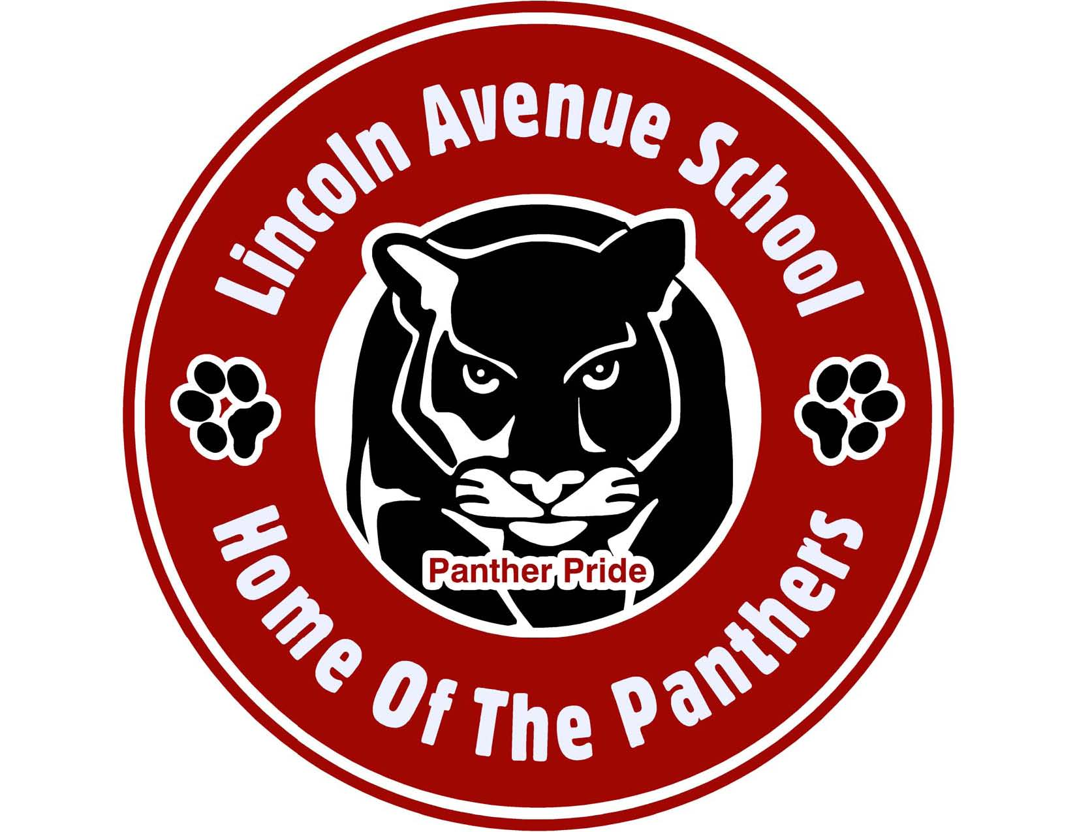

Denise V. White, Principal
Patrick Yearwood, Vice-Principal
Isabel Colon, Vice-Principal

FOCUS * DISCIPLINE * RESPECT

ORANGE BOARD OF EDUCATION

2014-2015

PATRICIA A. ARTHUR - SCHOOL BOARD PRESIDENT

Jeffrey Wingfield – Vice President

BOARD MEMBERS
Marion Graves-Jackson
Cristina Mateo
E. Lydell Carter
Abdul Shabazz Ashanti

SUPERINTENDENT OF SCHOOLS
RONALD C. LEE

DEPUTY SUPERINTENDENT
DR. PAULA HOWARD

ADMINISTRATIVE ASSISTANT TO THE SUPERINTENDENT
BELINDA S. SMILEY

BUSINESS ADMINISTRATOR/BOARD SECRETARY
ADEKUNLE JAMES

DIRECTORS
KATHRYN CARTER– LANGUAGE ARTS/LITERACY
CANDACE GOLDSTEIN –SPECIAL PROGRAMS
SHELLY HARPER –DIRECTOR SPECIAL SERVICES
DR. TINA POWELL – MATH/SCIENCE
DR. TERRI RUSSO – CURRICULUM & INSTRUCTION, PROFESSIONAL DEVELOPMENT AND ASSESSMENT

PRINCIPAL’S MESSAGE

I would like to take this opportunity to extend a warm welcome to parents and students of Lincoln Avenue School. As you know, Lincoln Avenue School is a special place that provides academic and social development while building our student’s self-esteem. We are proud of the successes that we have made and look forward to another exciting year of teaching and learning.

Our school is like a family, composed of a diverse group of educators, staff and parents all focused on one common goal, providing excellent academic services for all students. Your continued interest and participation will enhance the quality of education and activities at our school.

This handbook has been prepared to acquaint you with various policies, procedures and activities that have been developed in order to maintain a good education environment. Teachers, counselors and staff are always available to assist you in any way possible.

I look forward to working with you this school year and encourage you to become actively involved in your child’s educational experience.

DENISE WHITE, Principal

No Alibis, No Excuses, No Exceptions!

VISION STATEMENT

Students will become facilitators of their own knowledge utilizing best practices through focused lessons aligned to the Common Core State Standards that incorporate cooperative groups and engage in accountable talk. This process will enhance the teaching/learning experience for all stakeholders beyond the confinement of the classroom walls.

MISSION STATEMENT

- We believe in the innate ability of students to grow intellectually and to develop positive character traits through robust learning experiences which consistently increases the level of instructional rigor.

- We believe that Lincoln Avenue administration, instructional and support staff possess the knowledge and skills to assist students in meeting the expectations of the Common Core State Standards.

- We believe that mutual trust, respect and open communication between staff and families are critical for maximizing student achievement.

TABLE OF CONTENTS

- Board of Education Members
- Principal’s Message
- Vision and Mission Statement
- Lincoln School Shared Beliefs/Creed
- School Song
- Lincoln School Staff Roster and Room Assignments
- Attendance
- School Closing
- Homework Policy
- Progress and Report Card Dates
- Uniform Policy
- Cellular Phone Policy
- Lunch Forms
- Parking
- Classroom Visits
- Guidance
- Health Services
- Emergency Drills
- PTO News
- Code of Conduct
- Rules and Regulations
- Student Contract
- Parent’s Signature Page

LINCOLN AVENUE CREED

L We are LOYAL; we represent our family, school and community in a positive manner.

I We are INTELLIGENT; we study hard so we can learn much.

N We are NICE; we practice random acts of kindness.

C We are CONSIDERATE; we do not say or do hurtful things to others.

O We are OBEDIENT; we listen to our teachers and parents.

L We are LEADERS; we are accountable and responsible for our actions.

N We are NEAT; we take pride in our work, appearance and environment.

Lincoln Avenue School Song

We Dare To Excel

We dare to excel
We’re putting our best foot forward
We’re reaching our goals
We fly to the top at Lincoln Avenue School

I’m proud to be a student,
I’m proud to be apart-of,
Got the best education,

At Lincoln Avenue, Lincoln Avenue School!!!

ATTENDANCE

The school hours are 8:30 AM - 3:00 PM. Students should not arrive to school prior to 7:45 AM. Breakfast is served IN THE CAFETERIA from 7:45 AM– 8:15 AM. Instruction begins promptly at 8:30 AM. School ends promptly at 3:00 PM on FULL day sessions and 12:30 PM on HALF day sessions.

Morning supervision is available beginning at 7:45 AM. Sending or bringing your child to school before the scheduled opening is parental neglect and must not occur. Therefore, it is the parent’s responsibility to adhere to the school district’s scheduled hours. Those parents who are in violation will be reported to the Division of Youth and Family Services (DYFS). All children are expected to be picked up promptly at the close of school hours.
No supervision is available for students after that time

When children arrive to school in the morning, she/he can line up outside to be taken to their classroom by their teacher or Student Patrol Leader. Remember that children develop habits early in life. Coming to school on time everyday is one way to reinforce good attendance and foster good work habits. In order to do so, they first MUST come to school on time and be ready to learn.

Students are expected to report to school each day that school is in session. Illnesses, lack of proper immunizations, religious holidays, disciplinary action or death in the family are considered excused absences. Notify the school on the day of your child’s absence and submit a note explaining the child’s absence on his/her return to school. Students are responsible for all missed assignments.

If it is essential that your child be dismissed from school early, please send a written request to the classroom teacher. The child will be dismissed to the office and must be signed out by an adult. NO CHILD WILL BE ALLOWED TO GO HOME EARLY WITHOUT BEING ACCOMPANIED BY AN AUTHORIZED ADULT.

Important: Parents be reminded of the District’s Student Attendance Policy: Children may not accumulate more than 18 unexcused absences during the school year. Absence from school jeopardizes the ability of a child to satisfactorily complete the prescribed curriculum of study and violates the statues requiring children to attend school regularly. The interruption of the instructional process caused by frequent and/or repeated absences or lateness is a major concern for all involved. Note: Accrual of more than 18 unexcused absences from the school could jeopardize your child’s promotion to the next grade.

SCHOOL CLOSINGS / DELAYED OPENING

In the event of a school closing, or delayed opening the district will send out a telephone blast. It is imperative that you maintain current telephone numbers with the main office in case of an emergency.

Information will also be available through the following radio or TV stations between 6:30 AM - 9:00 AM for details:
WOR AM 710 | WINS AM 1010 | WFME FM 97.4
WRKS (KISS) FM 98.7 | WJDM AM 1530 | WADO (SPANISH) 1280
 | FOX - CHANNEL 5 TV
It is the responsibility of the parents and student to tune in for announcements of delayed opening or school closings. DO NOT CALL THE SCHOOL, CENTRAL OFFICE, BOARD MEMBER OR THE RADIO/TELEVISION STATIONS. The following procedures shall be followed whenever a delayed opening is announced:
- School will open a 10:00 AM for students
- The Breakfast Program will be CANCELED
- School will close at the regularly scheduled time

GRADING AND PROMOTION

The district grading and promotion policy can be found on the school and district website. This policy will be followed accordingly.

HOMEWORK POLICY

The primary purpose of homework is to foster responsibility for the learning process, time budgeting and prioritizing. It is an extension of the learning that occurs in the classroom each day and reinforces what is taught. The objective of assigning homework is to:

- Provide for essential practice in skills
- Enrich and extend classroom experiences and build positive work and study habits
- Provide experiences in finding resources and gathering data
- Encourage the development of self-discipline and integrity

The amount of time your child should spend on completing homework assignments may vary from grade to grade. For children in grades K-7 the following is a guide to the amount of time your child should spend on daily homework assignments:
GRADE | MINIMUM NUMBER OF MINUTES
KINDERGARTEN | 20 MINUTES 5 days a week
1st GRADE | 30 MINUTES 5 days a week
2nd GRADE | 40 MINUTES 5 days a week
3 & 4th GRADE | 60 MINUTES 5 days a week
5-7th GRADES | 90 MINUTES 5 days a week
It is highly recommended that all children read at least 30 minutes a day (in addition to homework). Parents can help by reading to their children or reading with their children (something that is informative or just for pleasure). The time-spent reading to your child/children will be invaluable. WE ASK THAT ALL PARENTS PLEASE SIGN YOUR CHILD’S HOMEWORK ASSIGNMENTS EACH NIGHT. Remember, when the school and parents work together and collaborate, our children are the beneficiaries.

UNIFORM POLICY

In June of 1996 the Orange Board of Education approved and implemented a mandatory K-12 District Uniform Dress Code Policy CODE # 5132 for ALL children who attend the Orange Public School System. It is expected that your child wear his/her uniform consistently every day. Parents of those children who are not in uniform will be contacted and reminded of the dress code policy. Sanctions will be imposed for those who continue to ignore the uniform policy. If there are extenuating circumstances that prevent you from adhering to this regulation, please contact the building principal. Only the approved school uniform dress code color components are acceptable as indicted below:

K-4 | 5-7
- White collared shirts short or long sleeves | - White collared shirts short or long sleeves
- Navy Blue pants, Bermuda shorts, skirts, skorts at knee length | - Khaki (tan) pants, Bermuda shorts, skirts, skorts at knee length
NO JEANS PERMITTED
PHYSICAL EDUCATION UNIFORM
Plain Navy Blue or Grey sweat pants or shorts, White T-shirt, and sneakers.
NO SWEATSHIRTS
Inclement/Cold Weather
Navy sweater/sweater vest may be worn over the uniform shirt. NO HOODED SWEAT SHIRTS ARE PERMITTED.

Parents who have gently used uniforms and are willing to donate to our school closet, is greatly appreciated. We will donate these uniforms to students who are in need.
NOTE: SAFE FOOTWEAR (PREFERABLY RUBBER SOLES) MUST BE WORN. NO FLIP FLOPS, SANDALS OR OPEN BACKED SHOES ARE ACCEPTABLE. SNEAKERS MUST BE WORN ON PHYSICAL EDUCATION DAYS. DISTRICT WIDE SKIRTS SHOULD BE NO SHORTER THAN 3 FINGERS LENGTHS ABOVE THE KNEE.
CLOTHING MUST BE CLEAN, IN GOOD CONDITION, AND WORN AS INTENDED AND DESIGNED. GOOD JUDGMENT SHOUD BE EXECUTED IN DRESSING. SKINTIGHT CLOTHING, ALONG WITH OTHER INAPPROPRIATE DRESS THAT IS DISTRACTING AND INTERFERS WITH THE EDUCTIOANAL PROCESS, IS NOT ACCEPTABLE.

CELLULAR PHONE POLICY

District policy prohibits students from carrying cell phones when on school grounds. Upon arriving on school premises students must turn their cell phones off and put them away. If a student is seen with a cell phone it will be confiscated. For the first offense the cell phone will be returned to the student at the end of the day. For the second offense the cell phone will only be returned to a parent. On the third offense the cell phone will be kept in the main office and returned at the end of the school year.

LUNCH FORMS

Each child in the school MUST have on file, a lunch application form for the Fiscal Year 2014-15 whether or not they are eligible for free or reduced lunch. If you have not filled out a form, please do so by Friday, September 19, 2014 and return it to the main office of the school. Each and every child must be included in the school’s Annual State Lunch Report.

PARKING

PLEASE DO NOT PARK IN FRONT OF THE SCHOOL DURING SCHOOL HOURS AND ESPECIALLY DURING DISMISSAL TIME. When you illegally park in front of the school exits, you block the view of other cars driving past making it difficult to see the children crossing the street. The Orange Police Department will issue citations to those individuals who ignore posted NO PARKING SIGNS. Barriers are positioned along the front yellow curb of the school to ensure that children are safe crossing the street and to allow those children who receive transportation easy access onto the school buses. Your cooperation is greatly appreciated.

CLASSROOM VISITS

The faculty and staff of Lincoln Avenue School are always glad to see and talk to parents. However, unannounced visits interrupt the classroom learning environment. All visitors must first sign in with the security desk and proceed to the main office for further instruction. If your child’s teacher is conducting a lesson, our secretary will be more than happy to assist you in scheduling an appointment to see the teacher at an appropriate time. Please do not go directly to your child’s classroom without reporting to the main office first. Teachers have been instructed to refer parents to the main office who do not have a visitor’s pass. Your cooperation would be greatly appreciated.

GUIDANCE SERVICES

At Lincoln Avenue School, we offer in-house counseling services to assist you and your child. These supported services are provided by certified trained professionals who will provide address those students who manifest emotional and social problems within the school setting. The guidance counselor and/or school’s social worker will assist your child in improving their peer relationships, developing good decision making skills, and developing strategies to cope with issues of stress they may face. They provide individual as well as group counseling, in addition to referrals for appropriate community agencies and services as needed. In addition, our guidance and counseling staff will identify factors that can make school a more successful, productive and happier experience for all our students and their families.

HEALTH AND NURSING SERVICES

The school nurse reviews immunization records, delivers medical care and first aid as well as screenings for height, weight, blood pressure, vision, hearing, and scoliosis when appropriate. Health information is shared with essential staff to assist your child in achieving his/her educational goals. Administration of medication in school requires a parent/guardian’s note and physician’s note with medicine in original containers. Questions regarding health concerns should be directed to the school nurse.
EMERGENCY DRILLS

Emergency drills are a serious and necessary exercise. State law requires that we hold emergency drills which may include fire drills, evacuations and/or lockdown exercises. Upon hearing the drill students should not panic but should move swiftly, safely and in a quiet manner. Engaging in these exercises will help us to maintain a safety for all students and staff members in case of an emergency.

PTO NEWS

“NOTHING IS MORE IMPORTANT TO SUCCESS IN SCHOOLS THAN THE QUALITY OF RELATIONSHIPS BETWEEN AND AMONG STUDENTS, STAFF, AND PARENTS”
Dr. James P. Comer

Please join and support the LAS PTO (Parent Teacher Organization). This is your organization. Your input, commitment and hard work are needed to support activities and programs in LAS. The PTO makes it possible for LAS to provide additional field trips, special events and rewards/incentives for our children during the school year. Your ideas and help are needed.

We are asking every family to join our PTO. Membership is $7 for 2 years or $5 for 1 year. Meetings will be held every 2nd Wednesday of the month in the LAS library at 5:00 pm. Contact the main office for any additional information. We look forward to seeing you there.

CODE OF STUDENT CONDUCT

Students learn best in a safe and orderly environment. One of the most important lessons education should teach is DISCIPLINE. While it does not appear as a subject, it underlies the whole educational structure. It is the training that develops self control, character, orderliness, and efficiency. It is the key to good conduct and proper consideration for other people. Students must conduct themselves in a proper manner at all times. This includes whether on the bus, at school, and at all school functions. All students are expected to abide by school and district policies and regulations at all times as noted in the Orange Code of Conduct Handbook. Failure to do this will bring about disciplinary action.

Student Responsibilities (RELATED TO DISCIPLINE)

• Respect the rights and privileges of others
• Accept responsibility for his/her actions and consequences of behavior
• Abide by the authority of teachers, staff, and adults
• Be regular and prompt in meeting all school responsibilities
• Help maintain school property free from damage and vandalism
Parental Responsibilities (RELATED TO DISCIPLINE)

Good discipline begins in the home. Parents are the child's first teachers. Through example and direct teaching, parents instill in children habits of acceptable behavior and positive attitudes.

As a parent, you can help us by doing the following:
- Support and assist the school in the administration of recommended consequences
- Provide your child with counseling, guidance and direct teaching of good habits and acceptable behavior
- Keep the line of communication between home and school open.
- Be sure to leave phone numbers with the school where you can be reached in case of an emergency
- Contact the school (973 677-4130) if you have any questions or have any important information to share
- If you have a problem or concern please contact your child’s teacher first.

11 NON-NEGOTIABLE RULES AND REGULATIONS

- Always put your academics first. Be on time and prepared for class. Bring books, paper, pencils and other necessary classroom materials.

- Move quickly from class to class: line-up quietly in the hall, when told, enter classrooms quietly, take your assigned seat, and begin work immediately. No bathroom/hall passes are given during the first 10 minutes or the last 10 minutes of the period.

- Do homework nightly. This is your opportunity to practice the skills taught and discover on your own.

- Turn in all cellular phones, iPods, video/sound recording devices, games, laser pens, other electronic devices and/or items not related to academic instruction to your homeroom teacher so they can be locked away until the end of the day. Failure to comply will lead to these items being confiscated until a parent conference is held.

- Be considerate, courteous and respectful. Inappropriate behavior includes rudeness, back talk, swearing, name-calling, putdowns, etc.

- We have a zero tolerance policy for bullying. Do not engage in physical or verbal violence. Learn to disagree without being disagreeable. Mediation is available for disagreements.

- Show respect for school property and the property of others. Inappropriate behavior includes: writing on or scratching school or other people’s property, or taking things without asking to borrow or use them.

- Wear your complete uniform daily. On Physical Education days: Grades K-4 wear the appropriate P.E. uniform to school. Grades 5-7 should wear school uniforms to school and bring PE uniforms with them to change in Gym locker rooms.

- Listen to and follow directions given by teachers, administrators, custodians, secretaries, instructional assistants, substitutes, and other adults in authority.

- Maintain integrity at all times. Cheating and plagiarism are unacceptable practices.

- Bring issues and concerns to the attention of an adult. Lincoln Avenue School staff members are here to educate and support you. Please be sure to express any concerns you have to make sure your time in school is as productive as possible.

Students who choose not to comply with the 11 non- negotiable rules and regulations can be subject to one or all the following consequences:
  - Verbal Reprimand
  - Parent Contact/Conference
  - During or After School Detention
  - Recommendation for exclusion of school activities including but field trips
  - In School Suspension
  - Out of School Suspension
Additional Administrative Action

Students who choose to comply with the 11 non- negotiable rules and regulations will receive the following incentives:
- Opportunity to acquire an education that will prepare you to be successful in any endeavor you choose.
- Opportunity to explore the world outside of Orange, N.J. by going on educational and social field trips.
- Recognition of your academic and behavioral successes with awards, rewards, dances, movie nights/afternoons, etc.

We would like to offer different rewards for your successes please list three things you would like to do.
1.__________________________________

2.__________________________________

3.__________________________________

By signing this contract you are agreeing to follow the 11 non-negotiable rules and regulation and ensure your academic success.

Name: ________________________________ Homeroom: _____________________

X____________________________________ Date: ______________________________
Student Signature

X____________________________________ Date: ______________________________
Parent Signature

Please note that the level of discipline is based on the severity of the misbehavior. In determining the level of seriousness of the misbehavior and the level of discipline necessary, the following factors will be considered:
• Student’s discipline history
• Degree of premeditation, impulse, or self-defense
• Age and/or disability
• Strength of evidence
• Cooperation/remorse

Final decisions will be made by the building principal.
Lincoln Avenue School
Parent & Student Handbook

Dear Parent:

Please review the information presented in our school handbook. In addition, please sign, date, and return this page to your child’s homeroom teacher. The handbook signature page must be returned. Your signature will confirm receipt of this very important document.

Sincerely,

Denise V. White
Principal

_________________________ ______________________________
Parent Name (please print) Parent Signature

_________________________ _____________________________
Student Name (please print) Grade/Homeroom

_________________________
Date

LINCOLN AVENUE SCHOOL


TEACHERS
COMMUNITY MEMBERS
STUDENTS
ADMINSTRATORS
PARENTS
SUPPORT STAFF

“WORKING TOGETHER”

